**DAY 5 REPORT ERROR HANDLING, TESTING, AND BACKEND INTEGRATION REFINEMENT**

1. The websitehas a good UI UX design and as soon as I click the shop option , it shows me a different route as shown in the second picture.

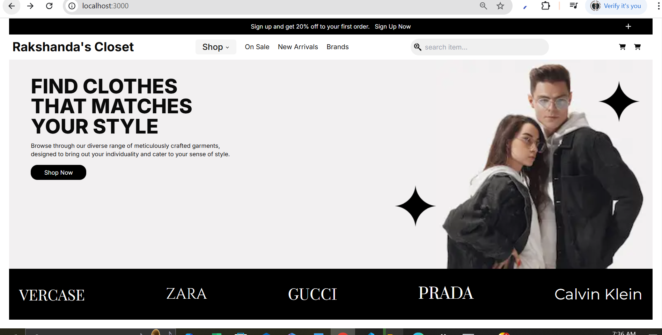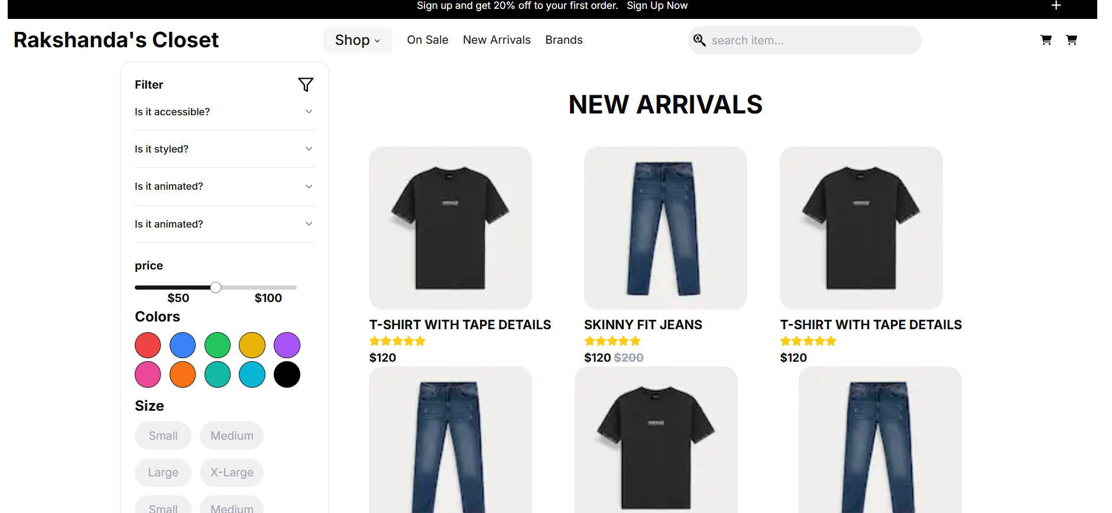

1. All products are fetched from sanity as shown below and dynamic outing for each product as shown below.

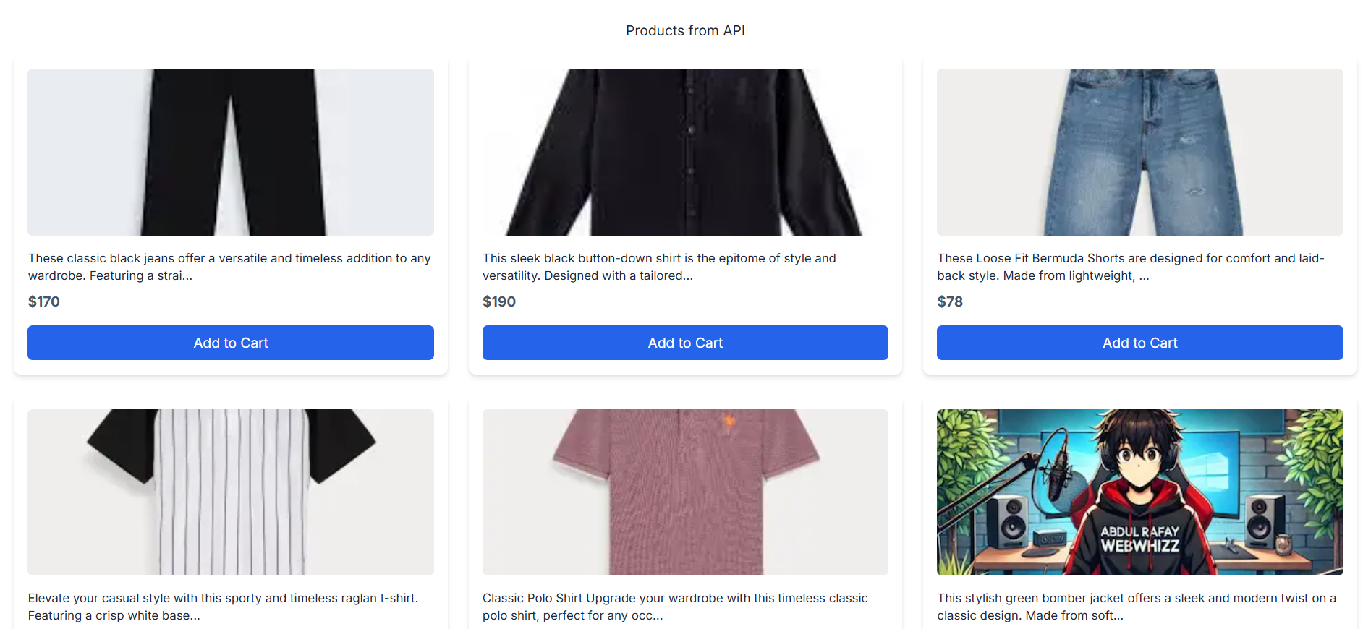 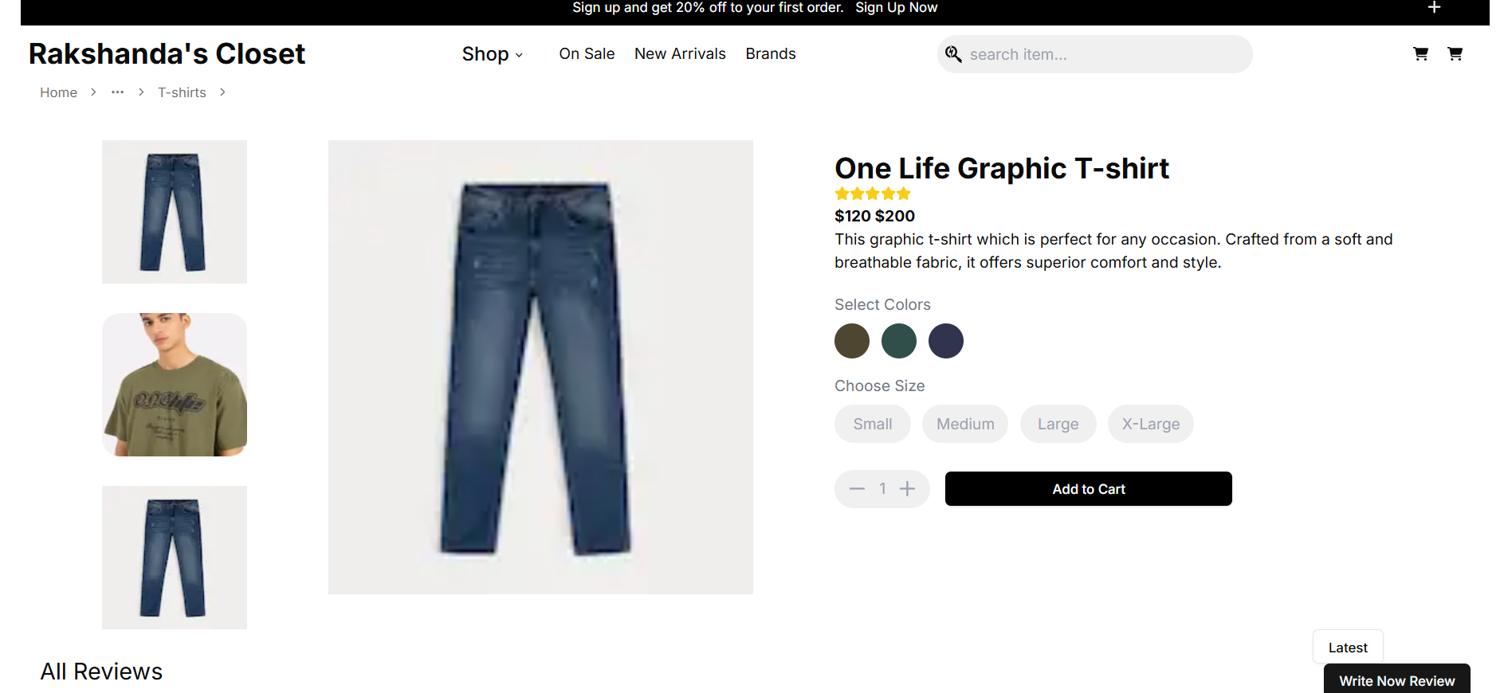

1. Add to cart functionality is also working fine with the notification of product added to the cart and removed from the cart.

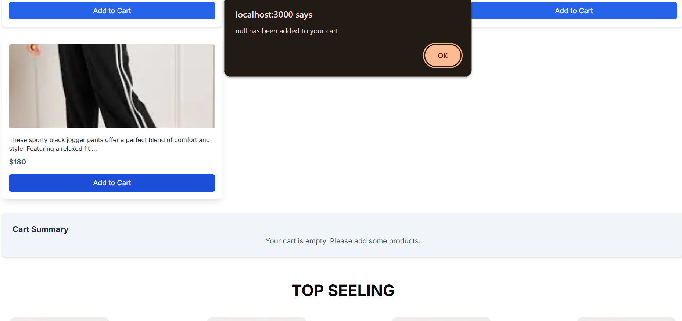 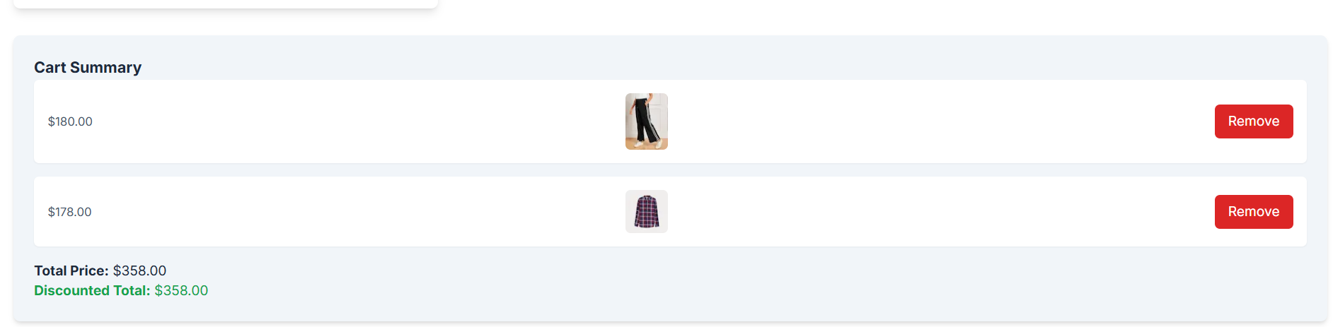

1. The website is completely responsive.

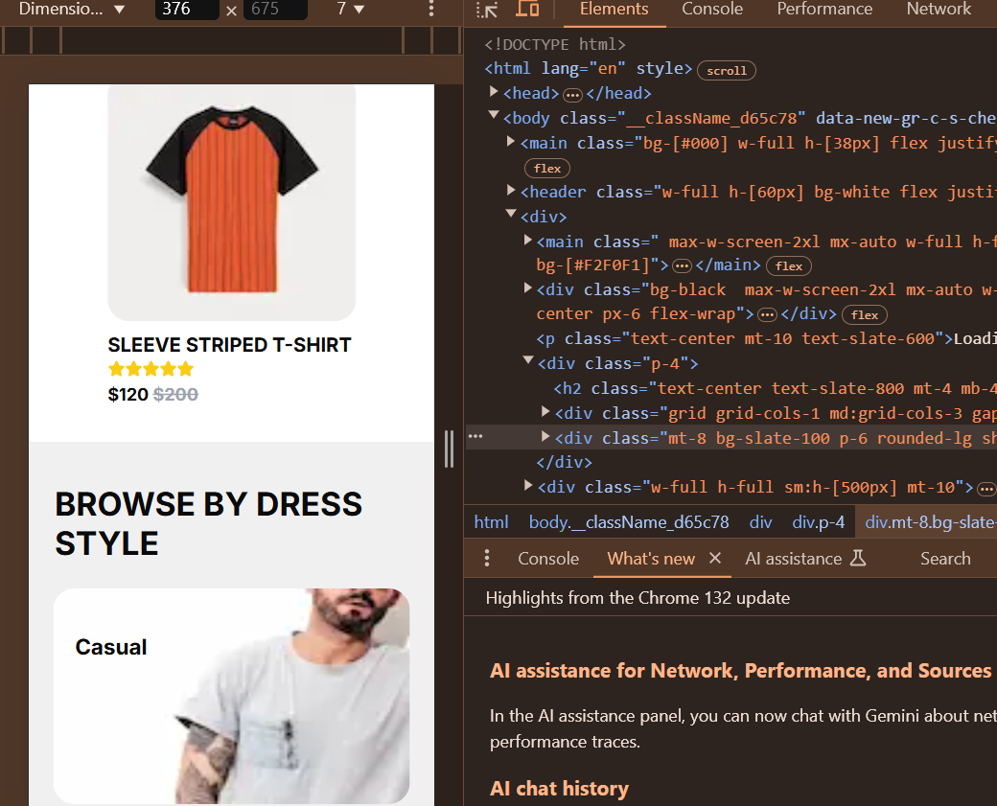

1. The data is rightly fetched from the API.

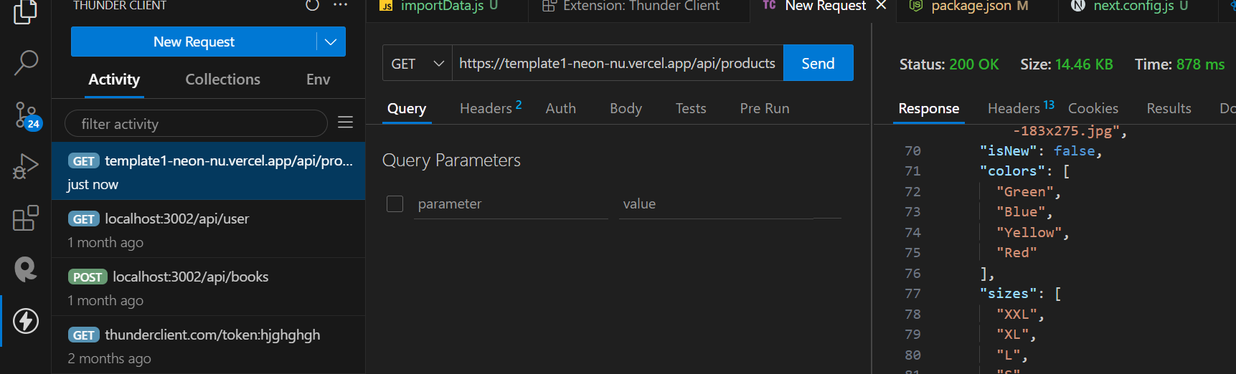

| **Test Case ID** | **Test Case Description** | **Test Steps** | **Expected Result** | **Actual Result** | **Status** | **Severity Level** | **Assigned To** | **Remarks** |
| --- | --- | --- | --- | --- | --- | --- | --- | --- |
| 2 | TC001 | Validate product listing page | Open product page > Verify products | Products displayed correctly | Products displayed correctly | Passed | High | - | No issues found |
| 3 | TC002 | Test API error handling | Disconnect API > Refresh page | Show fallback UI with error message | Error message shown | Passed | Medium | - | Success |
| 4 | TC003 | Check cart functionality | Add product to cart > Verify cart contents | Cart updates with added product | Cart updates as expected | Passed | High | - | Working |
| 5 | TC004 | Ensure responsiveness on mobile | Resize browser window > Check layout | Layout adjusts properly to screen size | Responsive layout working as intended | Passed | Medium | - | Test successful |

1. Lighthouse Report

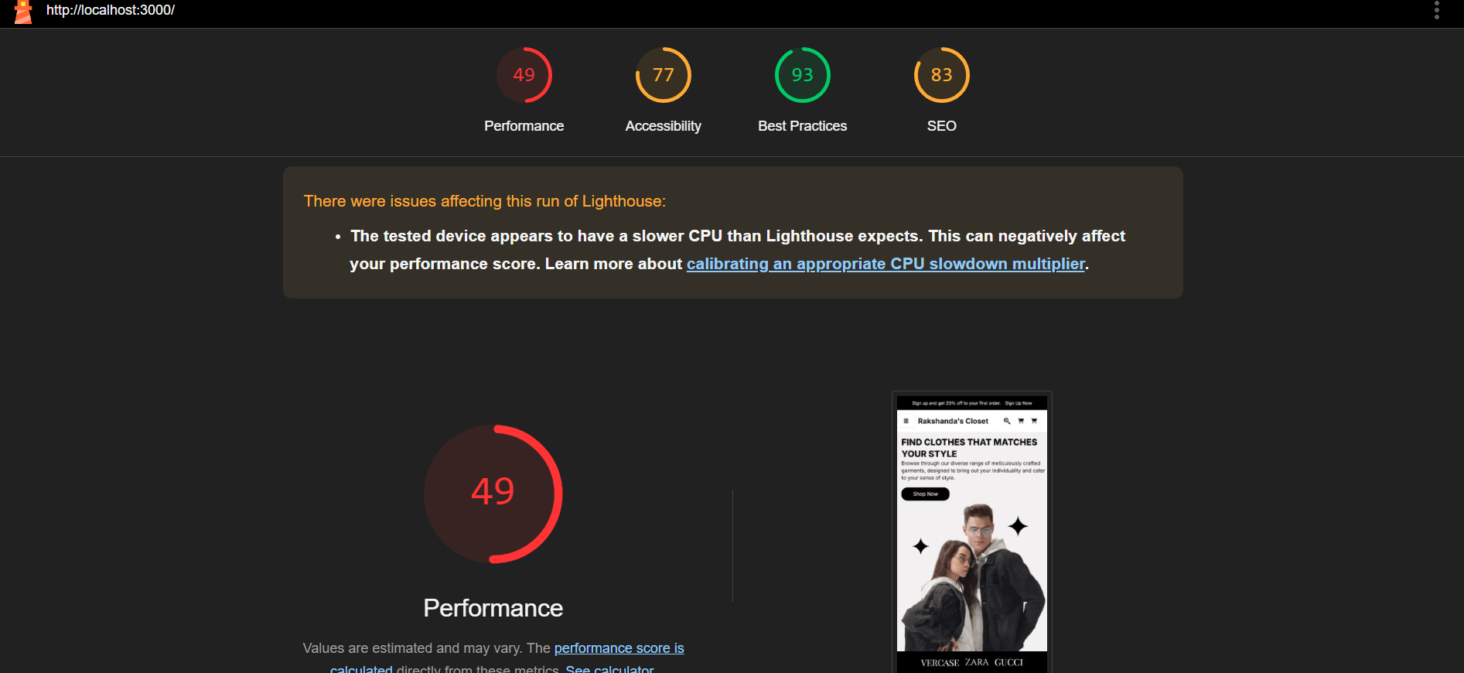

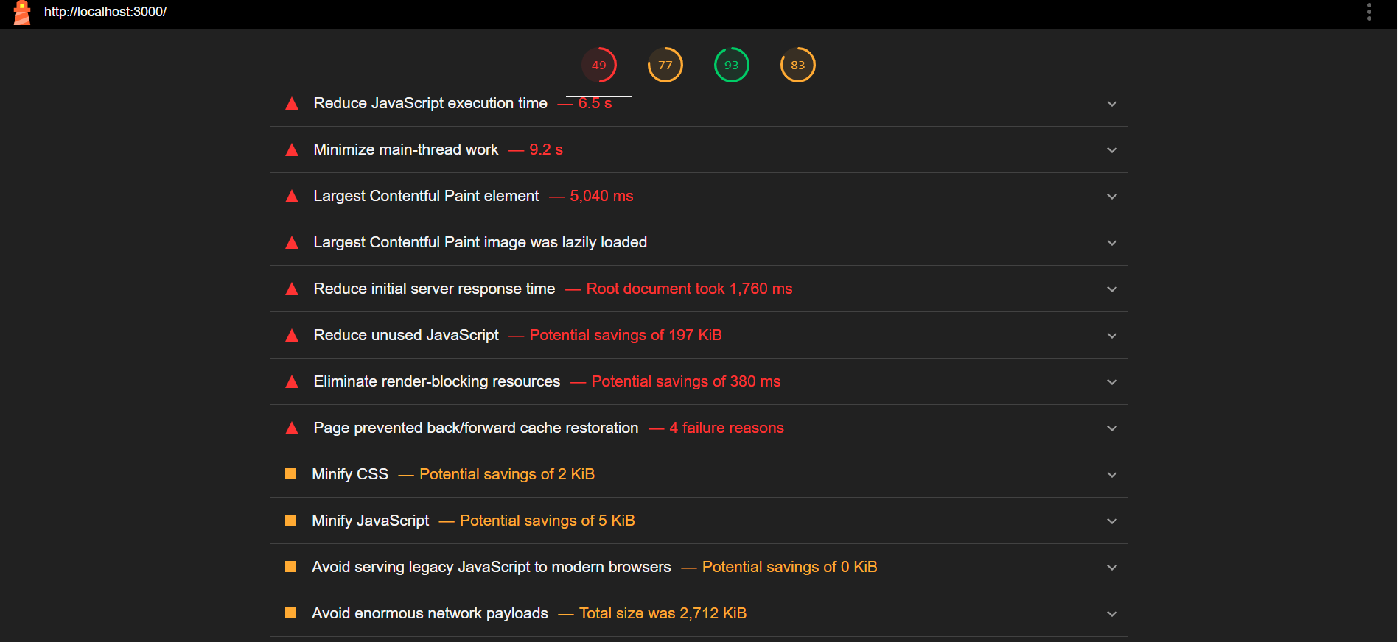

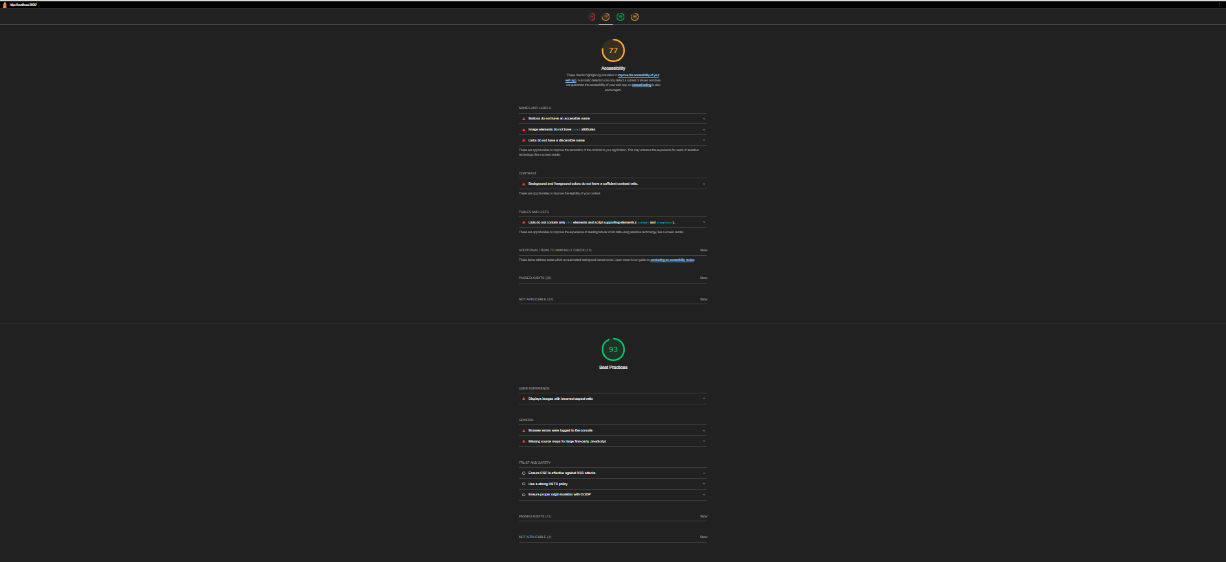



Ensure CSP is effective against XSS attacks

|  |  |  |
| --- | --- | --- |
|  |  |  |

Use a strong HSTS policy

|  |  |  |
| --- | --- | --- |
|  |  |  |

Ensure proper origin isolation with COOP

|  |  |  |
| --- | --- | --- |
|  |  |  |

Passed audits (12)

Show

|  |  |  |  |
| --- | --- | --- | --- |
|  |  |  |  |

Not applicable (2)

Show

83

SEO

These checks ensure that your page is following basic search engine optimization advice. There are many additional factors Lighthouse does not score here that may affect your search ranking, including performance on [Core Web Vitals](https://web.dev/explore/vitals?utm_source=lighthouse&utm_medium=cli). [Learn more about Google Search Essentials](https://support.google.com/webmasters/answer/35769).

Crawling and Indexing

robots.txt is not valid

Lighthouse was unable to download a robots.txt file

To appear in search results, crawlers need access to your app.

Content Best Practices

Image elements do not have [alt] attributes

Format your HTML in a way that enables crawlers to better understand your app’s content.

Additional items to manually check (1)

Show

Run these additional validators on your site to check additional SEO best practices.

Passed audits (7)

Show

Not applicable (1)

Show

* Captured at Feb 2, 2025, 10:33 AM GMT-7
* Emulated Moto G Power with Lighthouse 12.3.0
* Single page session
* Initial page load
* Slow 4G throttling
* Using Chromium 132.0.0.0 with cli

Generated by **Lighthouse** 12.3.0 | [File an issue](https://github.com/GoogleChrome/Lighthouse/issues)

Performance of website is lagging due to various malfunctions as stated above while accessibility and SEO looks okay.

Developer’s Resources:

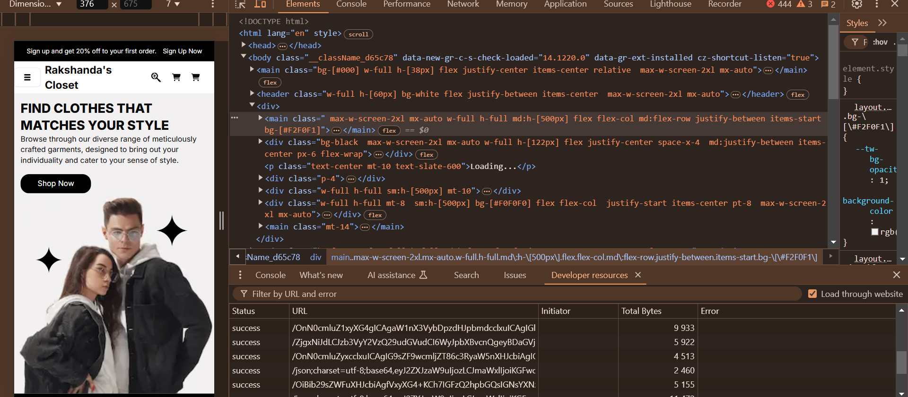

Performance Monitor:

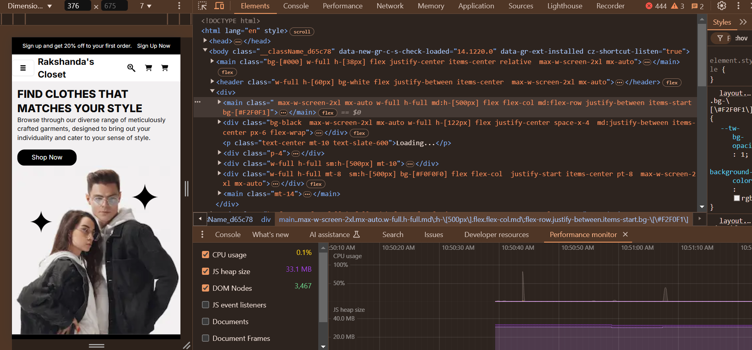

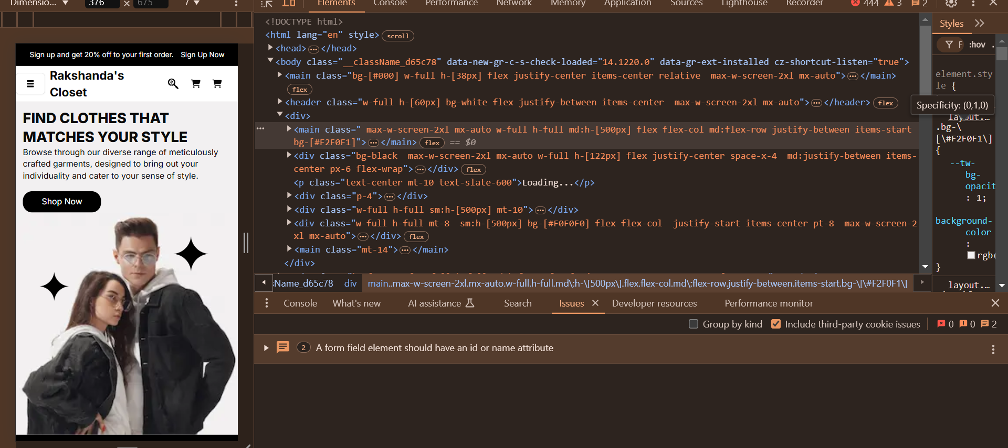

Security:

